TD53C20 Wiring Manual

Ver 1.0
Contents
1. Main Interface of TD53C20 3
1.1 TD53C20 Interface Diagram 3
1.2 Pin Definition of TD53C20 Interface Board’s Functional Interfaces 4
2. Appendix: Basic Connection 6
2.1 DIP1 Power Port 6
2.2 DIP1 Network Interface 6
2.3 DIP2 light board control signal input and output interface 7
2.4 DIP9/DIP11 Motor Interface 8

1. Main Interface of TD53C20

1.1 TD53C20 Interface Diagram

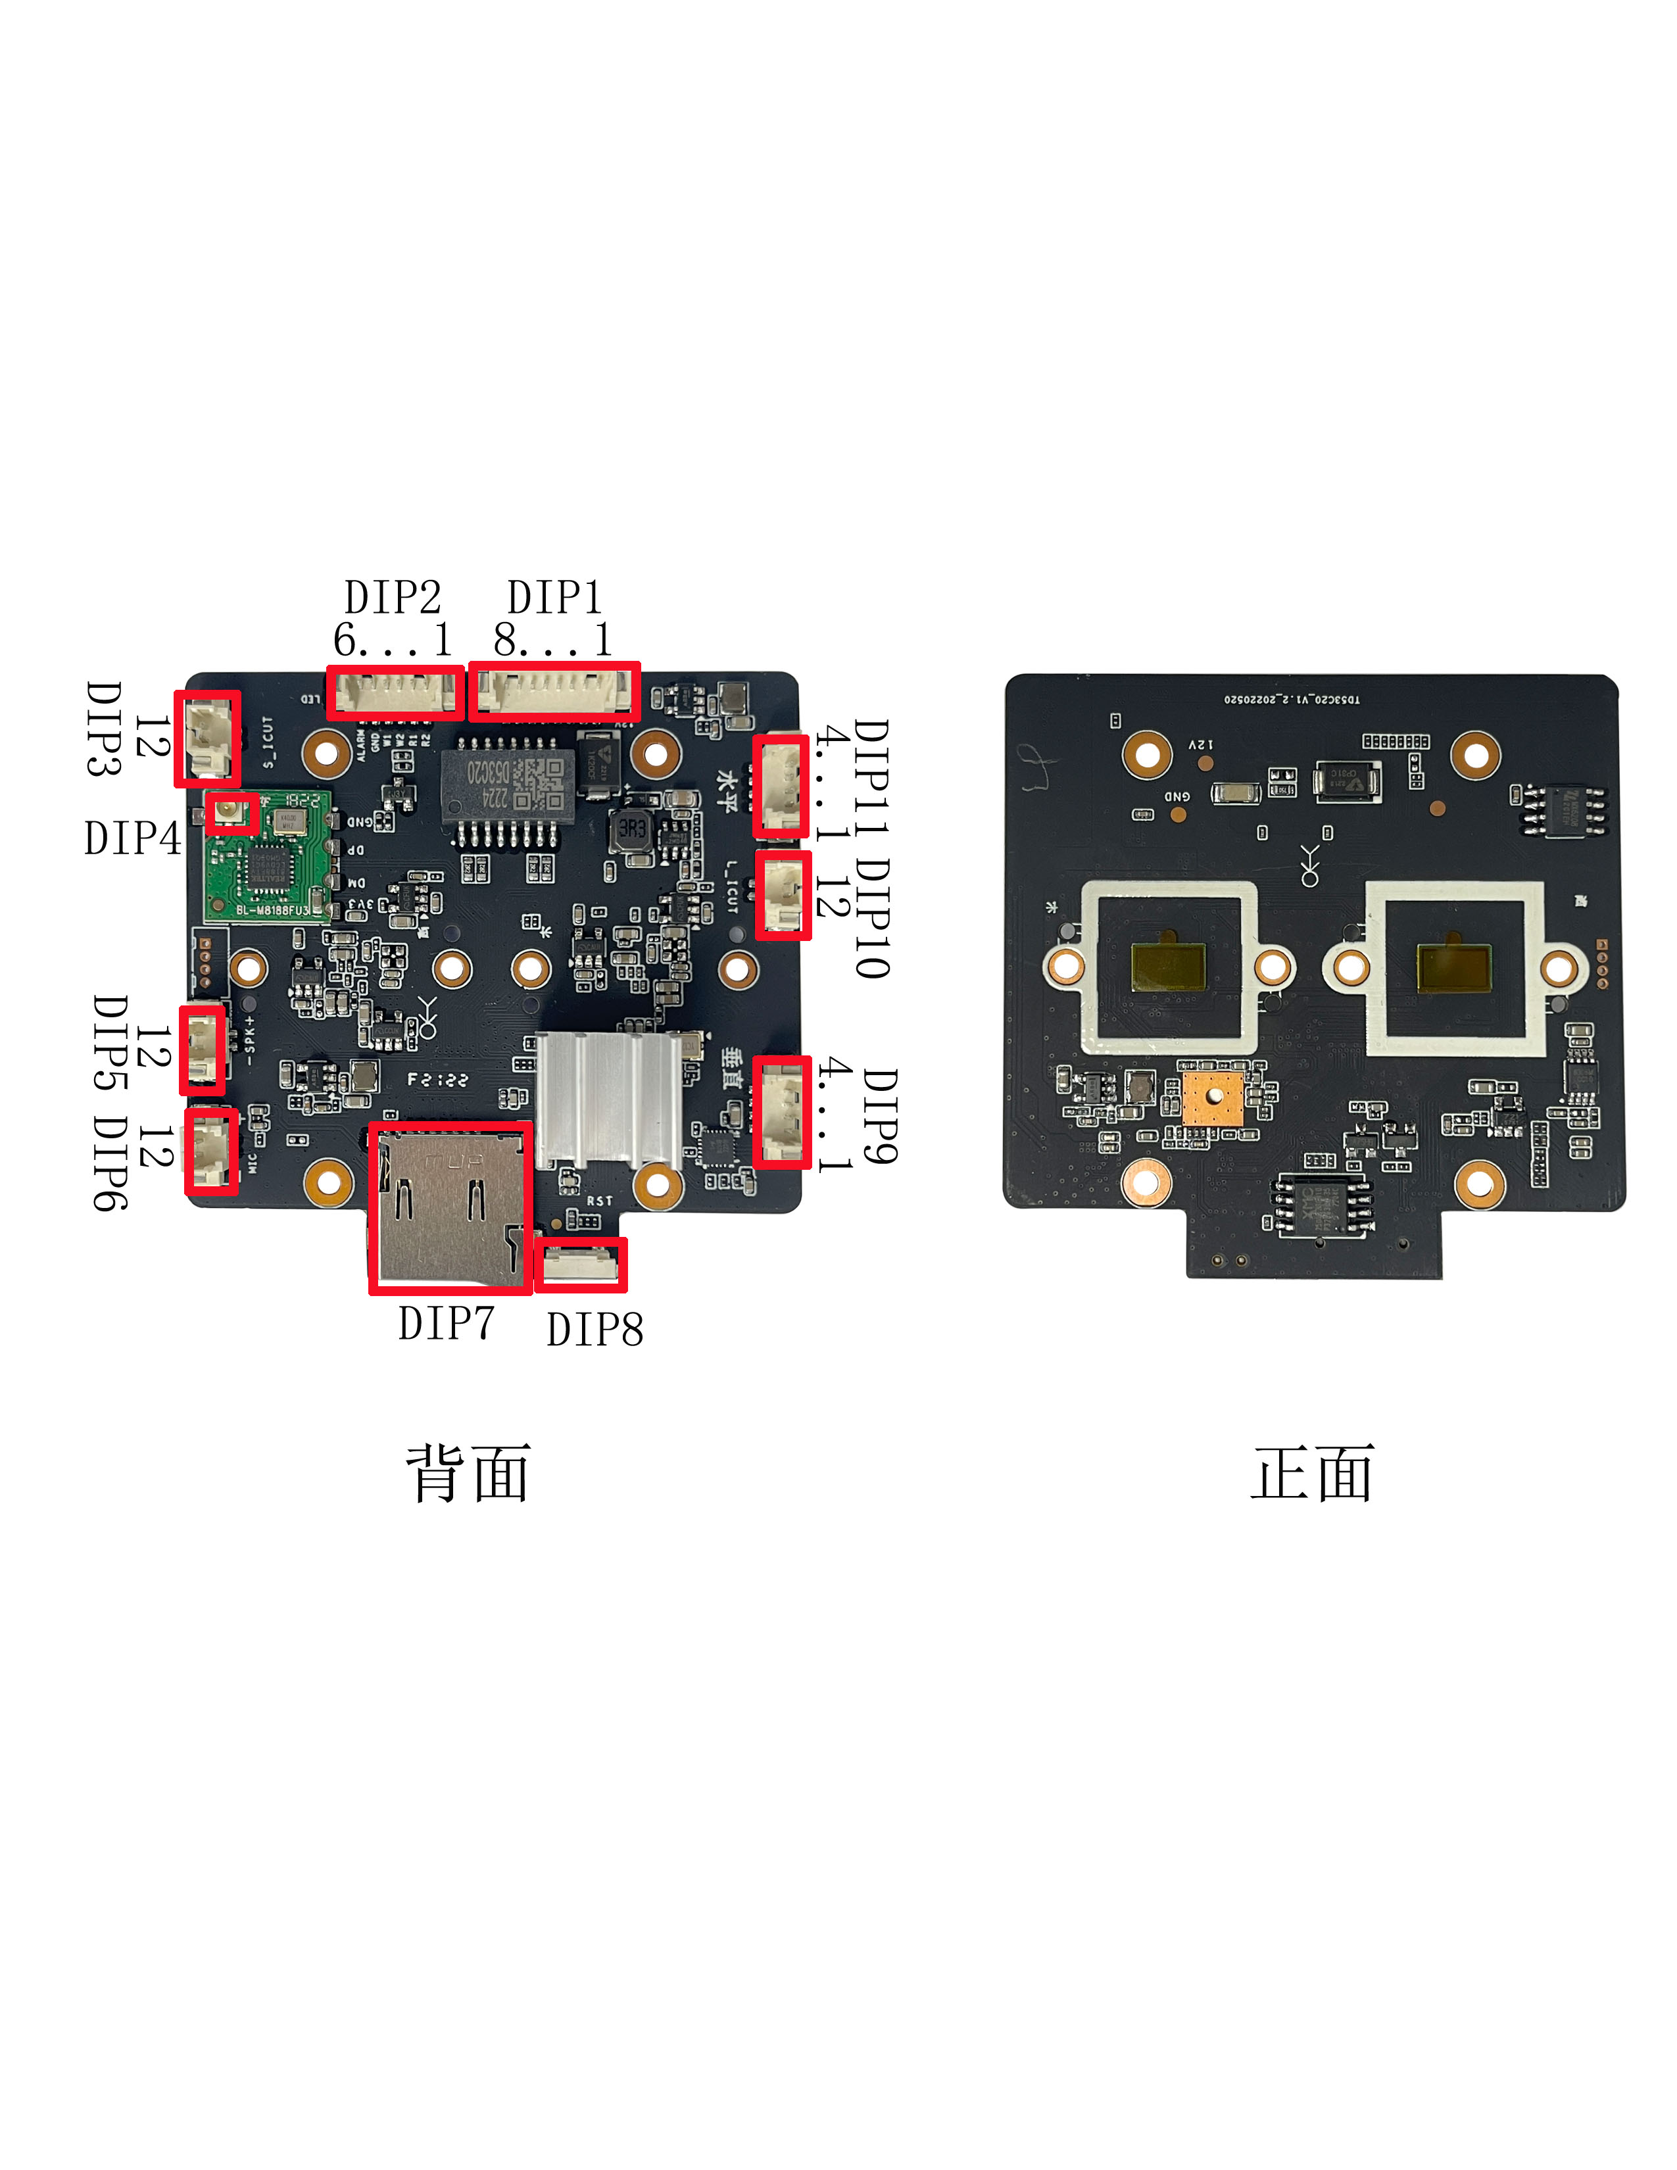

Veneer behind Interface Figure Veneer front Interface Figure

1.2 Pin Definition of TD53C20 Interface Board’s Functional Interfaces
DIP1：Power input and network interface
1 | DC12V
2 | GND
3 | Rx-
4 | Rx+
5 | Tx-
6 | Tx+
7 | RST
8 | ACT

DIP2：light board control signal input and output interface
1 | Infrared near light lamp
2 | Infrared high beam
3 | White near light lamp
4 | White high beam
5 | GND
6 | Alarm IO

DIP3：IR-CUT Interface
1 | IR-CUT connection port 1
2 | IR-CUT connection port 2

DIP4：WIFI antenna interface
Connect the WIFI antenna

DIP5：Audio output interface
Recommended horn 8Ω/2W
1 | Speaker positive
2 | Speaker Negative

DIP6：Audio input interface
1 | MIC positive
2 | MIC Negative

DIP7：T-flash card Socket
flash card Socket

DIP8：Reset key
Support Plate end reset

DIP9：Vertical motor control interface
1 | 1A
2 | 1B
3 | 2A
4 | 2B

DIP10：IR-CUT Interface
1 | IR-CUT connection port 1
2 | IR-CUT connection port 2

DIP11：Horizontal motor control interface
1 | 1A
2 | 1B
3 | 2A
4 | 2B

2. Appendix: Basic Connection

2.1 DIP1 Power Port
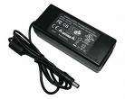
12V
GND
12V/2A

Power Supply
1
DIP1
2

2.2 DIP1 Network Interface
Example 1: Method of directly connect to network cable

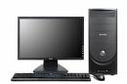

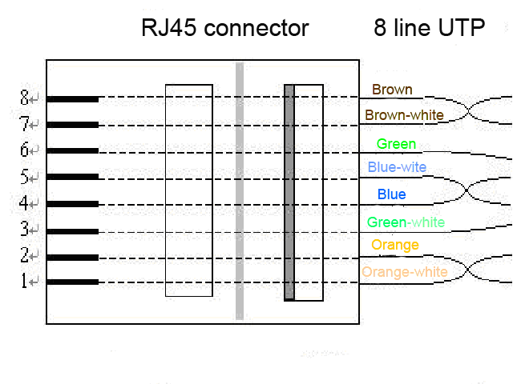
Green-white
Pick-up RST Reset Button
3 4 5 6 7 8
Orange
Orange-white
Green
6
3
1
2
GND

Example 2: Lead up to an RJ45 seat, then use the method of cross-wire and PC connection
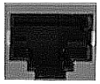
1.TX+
2.TX-
3.RX+
4.NU
5.NU
6.RX-
7.NU
8.NU
RJ45 Pin
3 4 5 6 7 8
DIP2
Cross line

2.3 DIP2 light board control signal input and output interface
1

2

3

4

5

6
Infrared near light lamp

Infrared high beam

White near light lamp

White high beam

GND

Alarm IO

2.4 DIP9/DIP11 Motor Interface
1）Horizontal/Vertical motor specifications

Serial number | Project | Specifications
1 | Voltage | 5V DC
2 | Number of phases | 4
3 | Slowdown ratio | 1:64

